**Assignment-6**

1) Write two different queries that would produce all orders taken on October 3rd or

4th, 1990.

Solution- select * from ORDERS WHERE Odate in('1990-10-03', '1990-10-04');

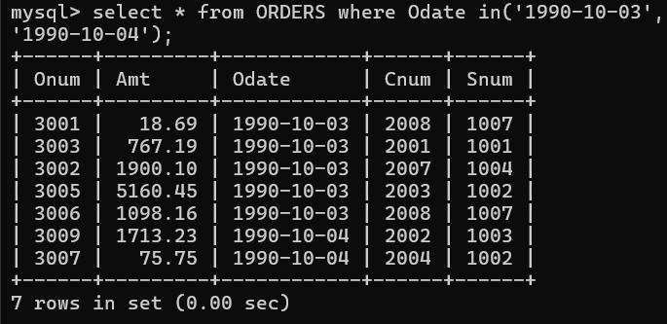

2) Write a query that selects all of the customers serviced by Peel or Motika.

(Hint: the snum field relates the two tables to one another).

Solution- select * from CUSTOMERS where Snum in(1001,1004);

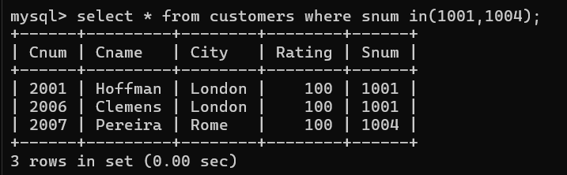

3) Write a query that will produce all the customers whose names begin with a letter

from ‘A’ to ‘G’.

Solution- select * from CUSTOMERS where Cname Between 'A' and 'G';

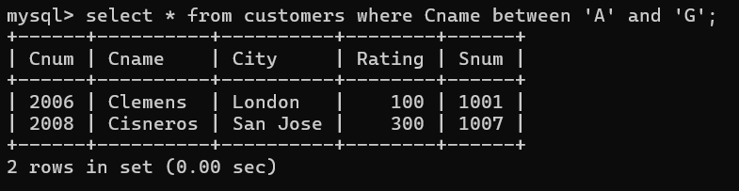

4) Write a query that selects all customers whose names begin with the letter ‘C’.

Solution- select * from CUSTOMERS where Cname like 'C%';

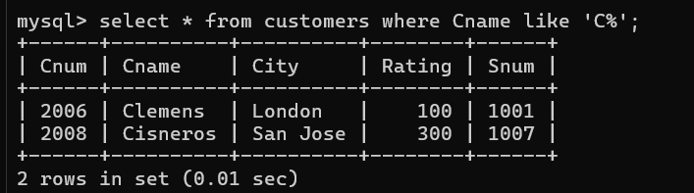

5) Write a query that selects all orders except those with zeroes or NULLs in the amt

field

Solution- select * from ORDERS where Amt > 0;

